Silvio O. Conte National Fish and Wildlife Refuge
US Fish and Wildlife Service
1
Issues Workbook

Let’s Get Started...
At this early stage of planning we are seeking your input via meetings, this workbook, and any other written or verbal comments submitted to us. We would like to hear directly from you - to learn how you feel about the Refuge, any issues or concerns you have, and any suggestions you may have about how to better accomplish our mission. We encourage you to provide comments to us as soon as possible. The sooner we receive your comments, the sooner we will be able to incorporate them into the planning process.
Thanks for taking the time to give us your input!

Questions on Values, Vision and the Service’s Role
- What do you value most about the Connecticut River and its watershed?

- What do you consider to be the most important problem facing the watershed?

3. Which of the following Refuge-sponsored activities have you heard about or participated in? Which do you think sound valuable? (Please place an X in the box corresponding with your answer)
US Fish and Wildlife Service
Activities | Heard About | Participated In | Valuable
Exhibits at the Montshire Museum
Educational programs at Montshire Museum
Exhibits at the Great North Woods Visitor Center
Programs at Great North Woods Visitor Center
Exhibits at Great Falls Discovery Center
Programs at Great Falls Discovery Center
Invasive plant control workshops for land managers
Invasive plant conferences
Volunteer invasive plant control projects
Endangered species volunteer work
Technical assistance from Refuge staff
Financial assistance through grants
Cooperative projects with partners in land protection
Cooperative projects with partners to control invasive species
Hunting on Refuge lands
Fishing on Refuge lands
Walking/hiking/skiing/snowshoeing on Refuge lands
Birding or other wildlife observation on Refuge lands
Photography on Refuge lands
Environmental education/interpretation programs on Refuge lands
Environmental education/interpretation programs at other outdoor locations sponsored by the Refuge
Snowmobiling on the Nulhegan Basin or Pondicherry Divisions

4. Where have you heard of the Refuge’s CCP efforts before?

Questions on Conservation
5. Please keep in mind that the U.S. Fish and Wildlife Service concentrates its efforts on migratory species and federally endangered species. In your opinion, which species or habitats should be a priority for the Refuge? Please rank the following in priority order (1 being the highest priority, 2 being the second highest, and so on). If you do not think we should be engaged in a choice, please place an X in the blank.
____ declining songbird populations
____ songbirds whose natural range is mostly in New England
____ migratory fish (e.g. Atlantic salmon, American shad, river herring, eels)
____ federally threatened and endangered species (piping plover, bald eagle, Puritan tiger beetle, dwarf wedge mussel, shortnose sturgeon. Jesup’s milk-vetch, small-whorled pogonia, northeast bulrush)
____ regionally declining plants
____ state-listed threatened and endangered species
____ rare habitats
____ protection of large blocks of forest
____ protection of large blocks of grassland
____ restoration of floodplain forests
____ protection/restoration of wetlands
____ protection/restoration of riparian areas
____ other ____________________________
6. Which tools should the Service use to help them conserve, protect, and enhance priority species and habitats? Please rank the following tools in priority order (1 being the highest priority, 2 being the second highest, and so on). If you do not think we should be engaged in a choice, please put an X in the blank.
____ land acquisition from willing sellers at market value
____ focused land management on appropriate Refuge lands (to enhance conditions for priority species)
____ conduct research on Refuge lands
____ conduct monitoring on Refuge lands
____ provide research and demonstration areas on Refuge lands
____ technical assistance to encourage focused land management on appropriate private lands
____ purchase of development rights
____ work with other agencies and conservation groups
____ work with private landowners
____ targeted education to decision makers and land managers
____ work to remove barriers to fish passage
____ work to improve in-stream habitats
____ other (please specify)____________________________
7. Which of the following issues should be a priority for the Refuge? Please rank the following issues in priority order (1 being the highest priority, 2 being the second highest, and so on). If you do not think we should be engaged in an issue, please place an X in the blank.
____ loss of habitat to suburban and industrial development
____ fragmentation of habitats by roads and development
____ lack of fish passage due to dams and culverts
____ impacts of human activities to water quality and aquatic habitats
____ loss of surface water levels or flow reductions due to water withdrawals
____ effects of recreational use on wildlife habitats
____ lack of management capability to maintain optimal habitats
____ displacement of native species by invasive exotic plants and animals
____ threats to federal-listed species
____ negative public sentiment toward certain management techniques (e.g. forestry, burning, herbicides)
____ other (please specify) ____________________________

Questions on Education
8. Please rank the topics you think we should be teaching in priority order (1 being the highest priority). If you do not think we should be engaged in a choice, please place an x in the blank.
____ general natural resource concepts
____ wildlife/habitat concepts
____ the needs of migratory species
____ the problems faced by endangered species
____ resource stewardship
____ how to control invasive species
____ how to manage land for wildlife
____ impact of personal choices on ecosystem health
____ value of biodiversity
____ how to connect with/enjoy the outdoors
____ others (please specify) ____________________________
9. Please rank the audiences you think we should be reaching in priority order (1 being the highest priority). If you do not think we should be engaged in a choice, please place an X in the blank.
____ K-12th grade students
____ teachers of K-12th grade students
____ nature center staffs
____ special audiences that can influence/solve certain problems (landowners, foresters, recreational users, etc.)
____ urban residents
____ rural residents
____ college students
____ families
____ others (please specify) ____________________________

10. Please rank the educational tools you think we should be using in priority order (1 being the highest priority). If you do not think we should be engaged in a choice, please place an X in the blank.
____ articles in newspapers and magazines
____ field trips and workshops
____ general educational programs
____ mobile exhibits that visit fairs, schools, nature centers
____ demonstration projects
____ others (please specify) ____________________________
Questions on Recreation and Public Access
While natural diversity conservation and ecosystem health are the Refuge’s primary purposes, some public uses can be allowed when they do not impact these resources. In fact, the National Wildlife Refuge System Improvement Act of 1997 identifies six priority wildlife-dependent public uses that are to receive enhanced consideration on national wildlife refuges: environmental education, interpretation, fishing, hunting, wildlife observation, and photography. These six uses will be evaluated in this planning process.
Other uses must be evaluated by the refuge manager to see if they are “appropriate” and “compatible.” Such things as whether the activity contributes to fulfilling the refuge’s purposes, its consistency with applicable laws, regulations and policies, whether it can be offered consistent with public safety, whether the refuge has the budget and staffing resources to administer the use, whether the activity will impair the existing wildlife-dependent recreational uses, whether the activity is available/can be done elsewhere, and anticipated impacts to resources are all considered prior to allowing uses.
11. Are any of these activities or current levels of use on the Refuge a concern?
wildlife viewing ___ photography ___
environmental education ___ interpretation ___
hunting ___ fishing ___
hiking ___ skiing/snowshoeing ___
snowmobile access ___ vehicle access ___
Please explain your concerns:

12. In your opinion, what other activities should occur on Refuge lands?

13. Have you used any of our recreational facilities (visitor/education centers, roads, trails, kiosks, other signage). Do they meet your needs?

14. Do you have other comments on recreational use?

That’s it! Thank you for your time.
IMPORTANT: Now that you are done, please separate pages 3-10 and mail them back to us by April 13, 2007. We will summarize these public comments and those received at the public meeting in our next newsletter. Please help us keep our mailing list updated by completing the following.
If you have specific challenges, needs, opportunities that you would like to bring to our attention, please attach information or contact us at anytime in the process.
If you wish to receive future “Planning Updates” about the Silvio O. Conte National Fish and Wildlife Refuge comprehensive conservation plan, please fill in the appropriate information below and return the with the Issues Workbook.

______ (Yes) Keep me on your mailing list/add me to your mailing list
______ (No) Take me off your mailing list.

Name: _______________________________________________
(Please Print)

Address: _______________________________________________

City: _______________________________________________

State ___________ Zip Code: ___________
If you are acting in an official capacity as the representative of an organization please complete the following two items.
Organization: _______________________________________
Title: _______________________________________
IMPORTANT: Please note that names on the CCP mailing list become part of the public record for this project. The Service must release names only, if requested, under the provisions of the Freedom of Information Act of 1974. To retain you on our mailing list we need your permission. Please sign below.
Signature: _______________________________________
Date: ____________________
U.S. Fish & Wildlife Service
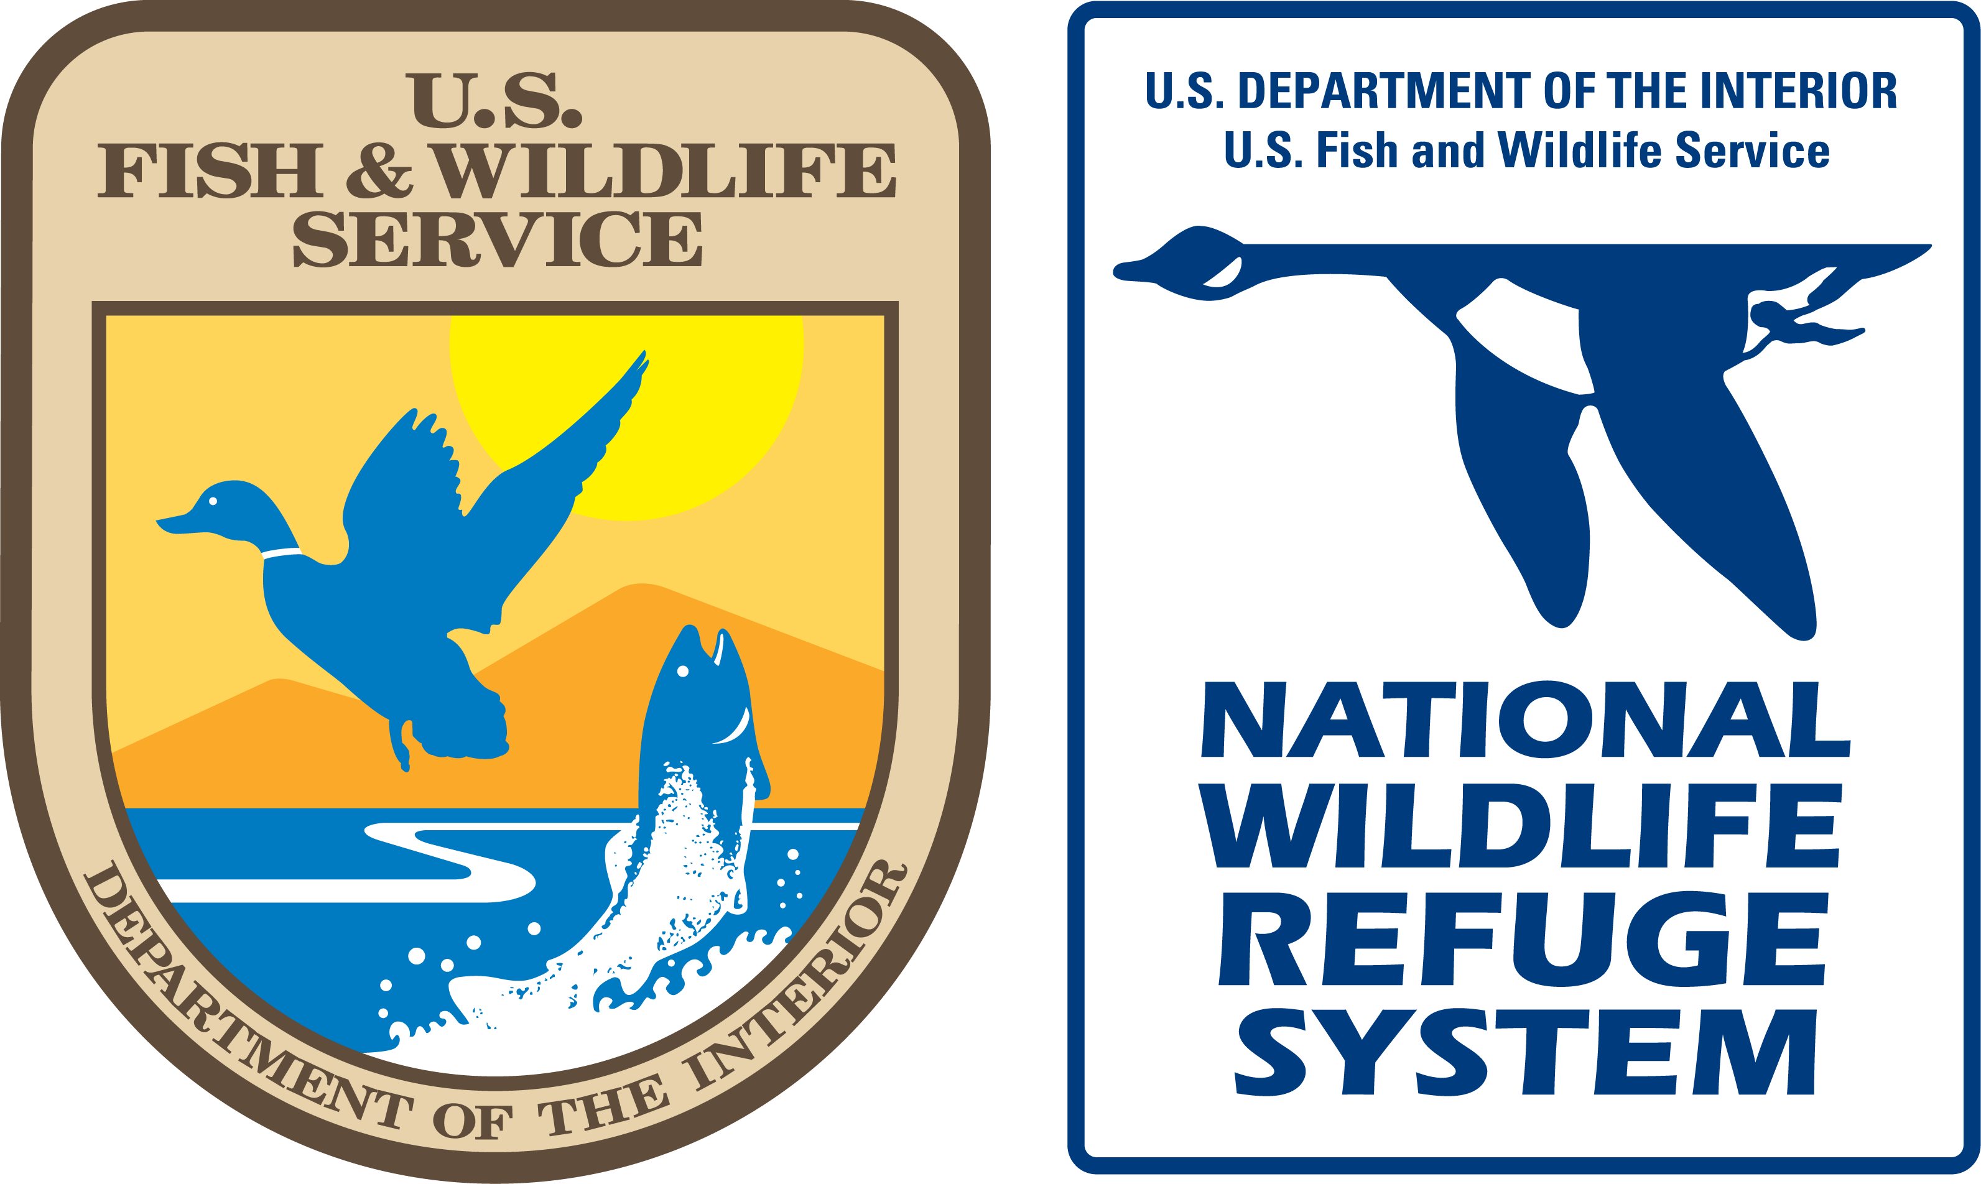
http://www.fws.gov

March 2007

